CSA1708-ARTIFICIAL INTELLIGENCE
LAB EXPERIMENTS
Program 17 : Prolog Program to Sum the Integers from 1 to N
Aim
To write a recursive Prolog program that calculates the sum of integers from 1 to N.
Algorithm
1. Define the base case: the sum of integers up to 0 is 0.
2. For a positive N, reduce it by 1 and recursively find the sum up to N - 1.
3. Add N to the partial sum returned by the recursive call.
4. Query the predicate with a number and display the resulting sum.
Program
sum_to_n(0, 0).

sum_to_n(N, Sum) :-
N > 0,
Previous is N - 1,
sum_to_n(Previous, PartialSum),
Sum is N + PartialSum.
Sample Input
?- sum_to_n(5, Sum).
Program Execution
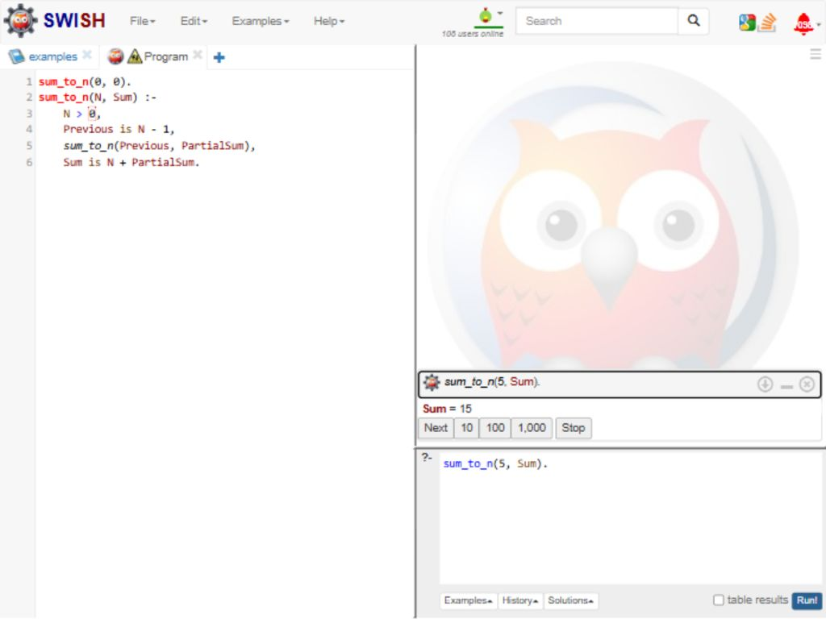
RESULT
Thus, the Prolog program recursively calculated the sum from 1 to 5 as 15.

CSA1708-ARTIFICIAL INTELLIGENCE
LAB EXPERIMENTS
Program 18 : Prolog Program for a Database with Name and Date of Birth
Aim
To create a Prolog database that stores names and dates of birth and retrieves a person's birth date.
Algorithm
1. Add person facts containing a name and a date(day, month, year) value.
2. Define a rule that matches a name with its date fields.
3. Query the rule with a name and variables for the day, month, and year.
4. Read the values returned by Prolog.
Program
person(aarav, date(12, 5, 2004)).
person(priya, date(3, 9, 2003)).
person(rahul, date(21, 1, 2005)).
person(sneha, date(8, 12, 2004)).

birth_date(Name, Day, Month, Year) :-
person(Name, date(Day, Month, Year)).
Sample Input
?- birth_date(priya, Day, Month, Year).
Program Execution
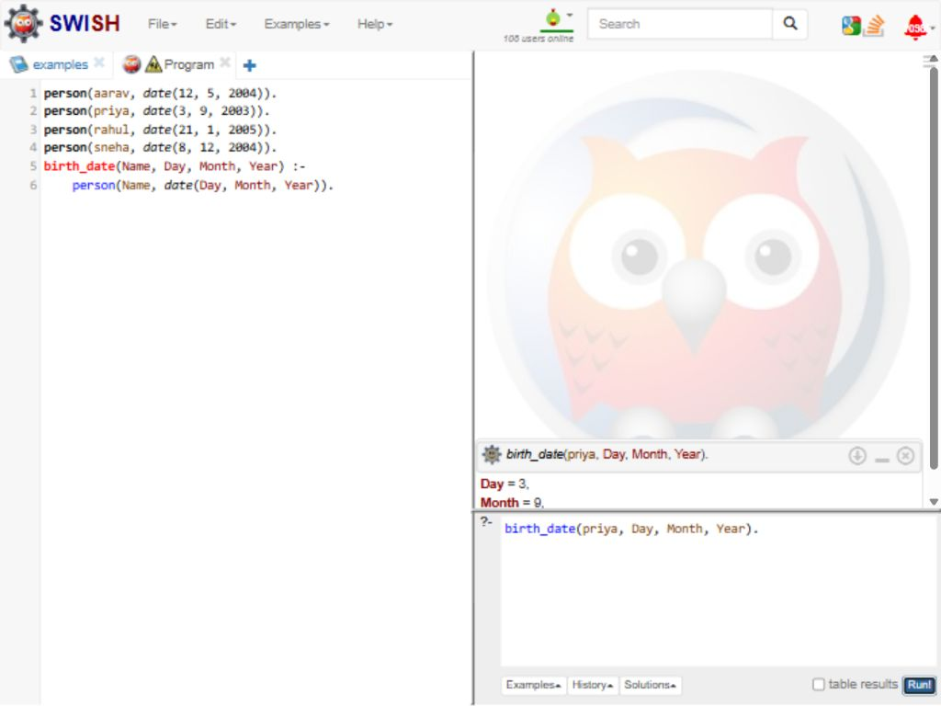
RESULT
Thus, the Prolog database stored names and dates of birth and returned Priya's birth date as 3 September 2003.

CSA1708-ARTIFICIAL INTELLIGENCE
LAB EXPERIMENTS
Program 19 : Prolog Program for Student Teacher Subject Code Database
Aim
To create a Prolog database that connects students with their teachers and subject codes.
Algorithm
1. Store student IDs with student names as facts.
2. Store teacher IDs with teacher names as facts.
3. Add facts linking each student and teacher to a subject code.
4. Use a rule to join the facts and return a student's teacher and subject code.
5. Query the rule with a student name.
Program
student(101, anita).
student(102, rahul).
teacher(t1, mr_kumar).
teacher(t2, ms_sharma).
student_subject(101, sub01).
student_subject(102, sub02).
teacher_subject(t1, sub01).
teacher_subject(t2, sub02).

class_details(StudentName, TeacherName, SubjectCode) :-
student(StudentId, StudentName),
student_subject(StudentId, SubjectCode),
teacher_subject(TeacherId, SubjectCode),
teacher(TeacherId, TeacherName).
Sample Input
?- class_details(anita, Teacher, Code).
Program Execution
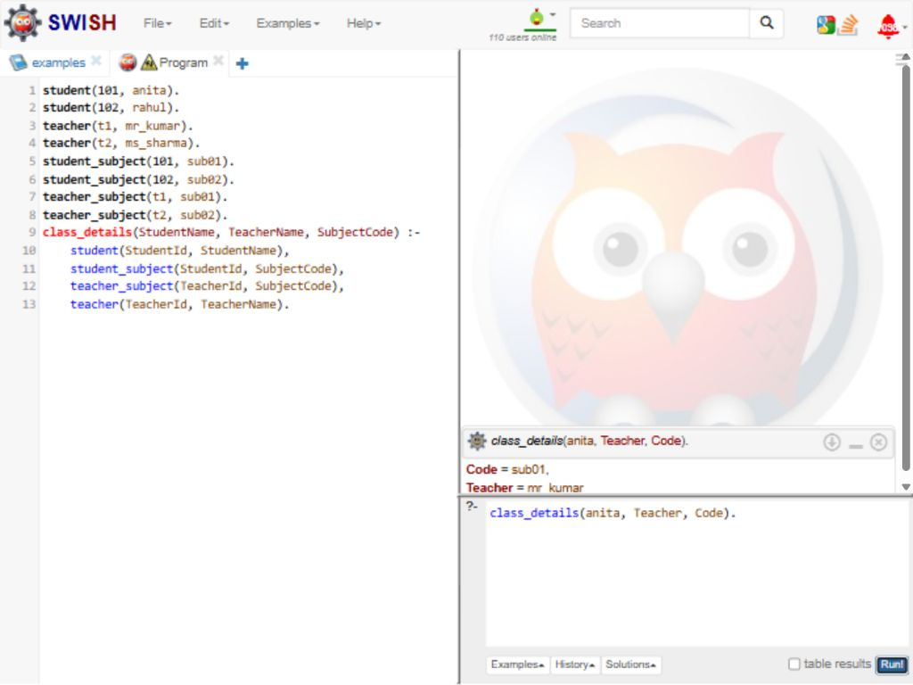
RESULT
Thus, the Prolog database returned Mr Kumar and subject code sub01 for student Anita.

CSA1708-ARTIFICIAL INTELLIGENCE
LAB EXPERIMENTS
Program 20 : Prolog Program for Planets Database
Aim
To create a Prolog database of the eight planets and query each planet's position and type.
Algorithm
1. Store each planet's name, order from the Sun, and type as a fact.
2. Define a rule that retrieves those details from the database.
3. Query the rule using a planet name.
4. Read the position and type returned by Prolog.
Program
planet(mercury, 1, terrestrial).
planet(venus, 2, terrestrial).
planet(earth, 3, terrestrial).
planet(mars, 4, terrestrial).
planet(jupiter, 5, gas_giant).
planet(saturn, 6, gas_giant).
planet(uranus, 7, ice_giant).
planet(neptune, 8, ice_giant).

planet_info(Name, Position, Type) :-
planet(Name, Position, Type).
Sample Input
?- planet_info(neptune, Position, Type).
Program Execution
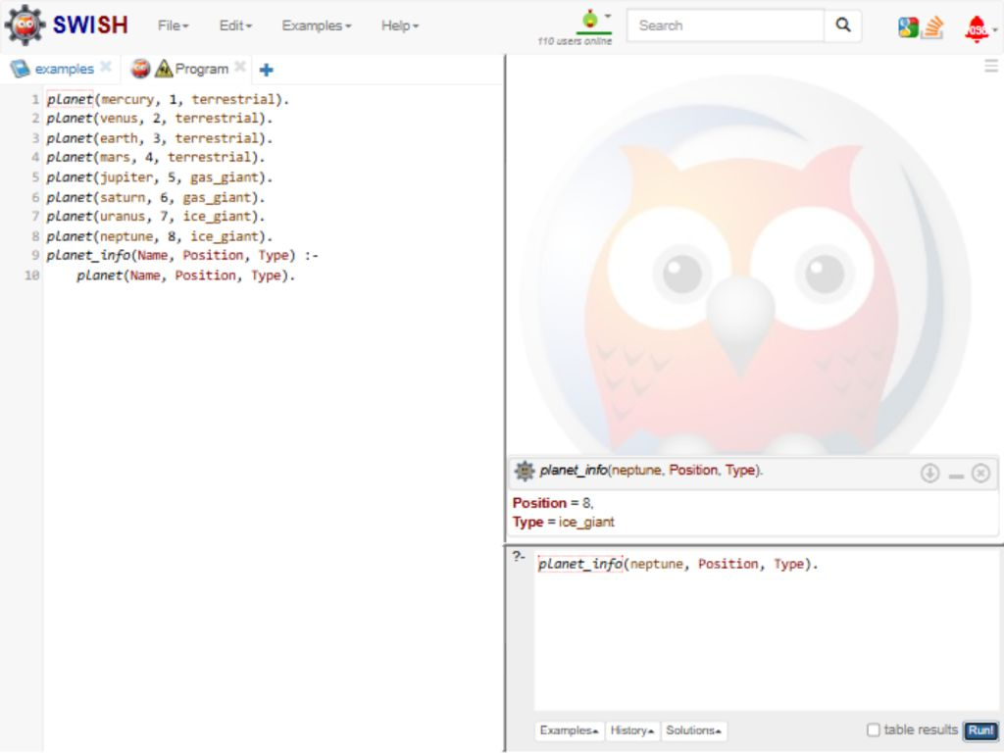
RESULT
Thus, the Prolog database returned position 8 and type ice_giant for Neptune.

CSA1708-ARTIFICIAL INTELLIGENCE
LAB EXPERIMENTS
Program 21 : Prolog Program to Implement Towers of Hanoi
Aim
To use recursion in Prolog to list the legal moves for a positive number of disks in the Towers of Hanoi puzzle.
Algorithm
1. If one disk remains, move it directly from the source peg to the destination peg.
2. Move the top N - 1 disks from the source peg to the auxiliary peg, using the destination as the spare peg.
3. Move the largest disk from the source peg to the destination peg.
4. Move the N - 1 disks from the auxiliary peg to the destination peg.
Program
hanoi(1, From, To, _) :-
format('Move disk from ~w to ~w~n',
[From, To]).

hanoi(N, From, To, Aux) :-
N > 1,
Next is N - 1,
hanoi(Next, From, Aux, To),
format('Move disk from ~w to ~w~n',
[From, To]),
hanoi(Next, Aux, To, From).
Sample Input
?- hanoi(3, left, right, middle).
Program Execution
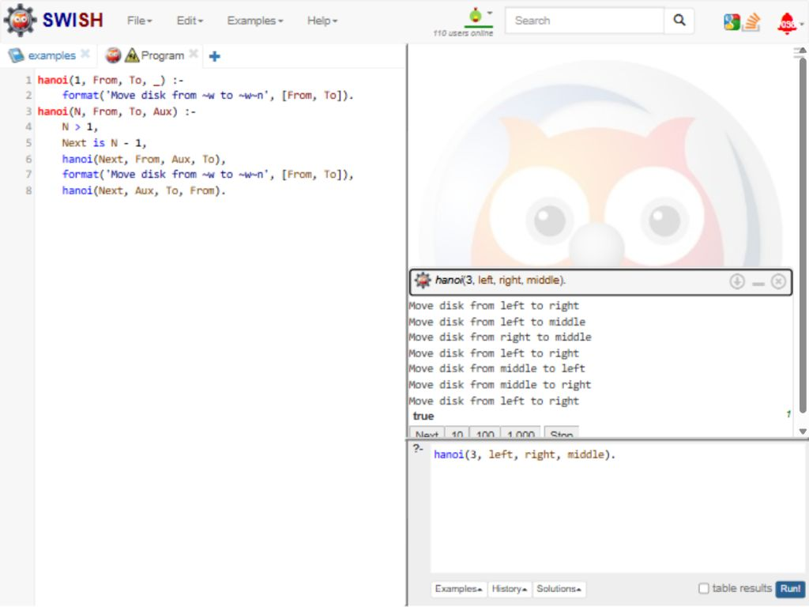
RESULT
Thus, the recursive Prolog program displayed the seven legal moves needed to transfer three disks from the left peg to the right peg.

CSA1708-ARTIFICIAL INTELLIGENCE
LAB EXPERIMENTS
Program 22 : Prolog Program to Check Bird Flight
Aim
To use Prolog facts and rules to print whether a selected bird can fly.
Algorithm
1. Store facts for birds that can fly and birds that cannot fly.
2. Define a rule that prints a message for a flying bird.
3. Define another rule that prints a message for a flightless bird.
4. Query the program with a bird name to display its flight status.
Program
can_fly(sparrow).
can_fly(pigeon).
can_fly(eagle).
cannot_fly(penguin).
cannot_fly(ostrich).

bird_status(Bird) :-
can_fly(Bird),
format('~w can fly.~n', [Bird]).
bird_status(Bird) :-
cannot_fly(Bird),
format('~w cannot fly.~n', [Bird]).
Sample Input
?- bird_status(sparrow).
?- bird_status(penguin).
Program Execution
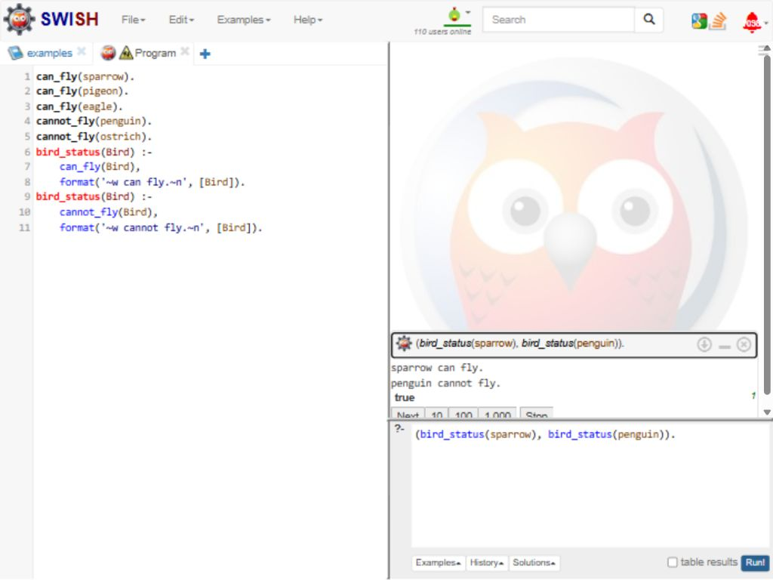
RESULT
Thus, the sample queries reported that sparrow can fly and penguin cannot fly according to the stored facts.

CSA1708-ARTIFICIAL INTELLIGENCE
LAB EXPERIMENTS
Program 23 : Prolog Program to Implement Family Tree
Aim
To model family relationships in Prolog and answer relationship queries.
Algorithm
1. Add male, female, and parent facts for family members.
2. Define father and mother rules using the facts.
3. Define grandparent and sibling rules from parent facts.
4. Run queries to check the required family relationships.
Program
male(john).
male(peter).
female(mary).
female(alice).
female(susan).
parent(john, mary).
parent(john, peter).
parent(mary, alice).
parent(peter, susan).

father(X, Y) :- male(X), parent(X, Y).
mother(X, Y) :- female(X), parent(X, Y).
grandparent(X, Z) :- parent(X, Y), parent(Y, Z).
sibling(X, Y) :- parent(P, X), parent(P, Y), X \= Y.
Sample Input
?- mother(mary, alice).
?- grandparent(john, susan).
?- sibling(mary, peter).
Program Execution
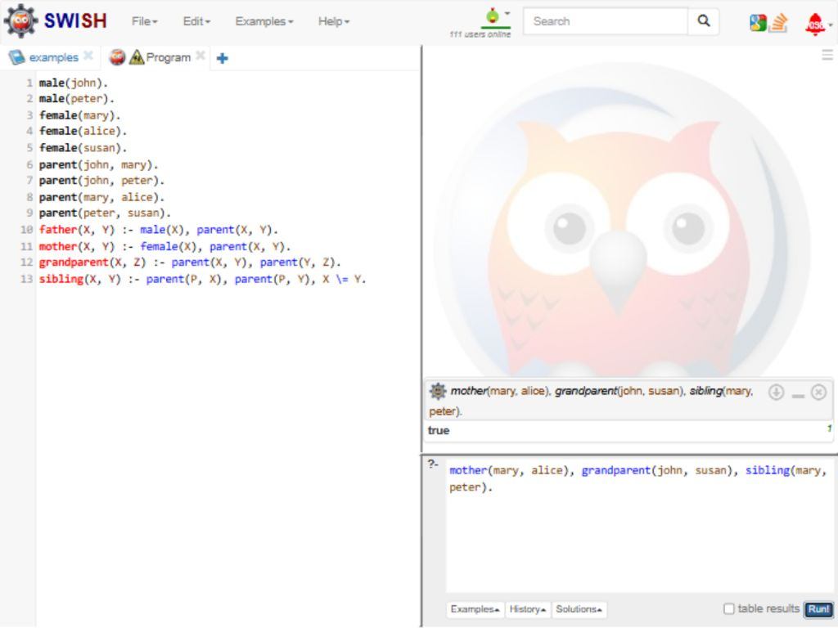
RESULT
Thus, all three family relationship queries returned true.

CSA1708-ARTIFICIAL INTELLIGENCE
LAB EXPERIMENTS
Program 24 : Prolog Program for Diet Suggestion Based on Disease
Aim
To use Prolog to retrieve sample diet options by disease.
Algorithm
1. Store diseases and example diet options as facts.
2. Define a rule to match a disease with its options.
3. Query the rule with a selected disease.
4. Use backtracking to display additional matching options.
Program
diet(diabetes, 'low-sugar meals').
diet(diabetes, 'whole grains and vegetables').
diet(hypertension, 'low-salt meals').
diet(hypertension, 'fruits and vegetables').
diet(anemia, 'iron-rich foods').

suggest(Disease, Food) :-
diet(Disease, Food).
Sample Input
?- suggest(diabetes, Food).
?- suggest(anemia, Food).
Program Execution
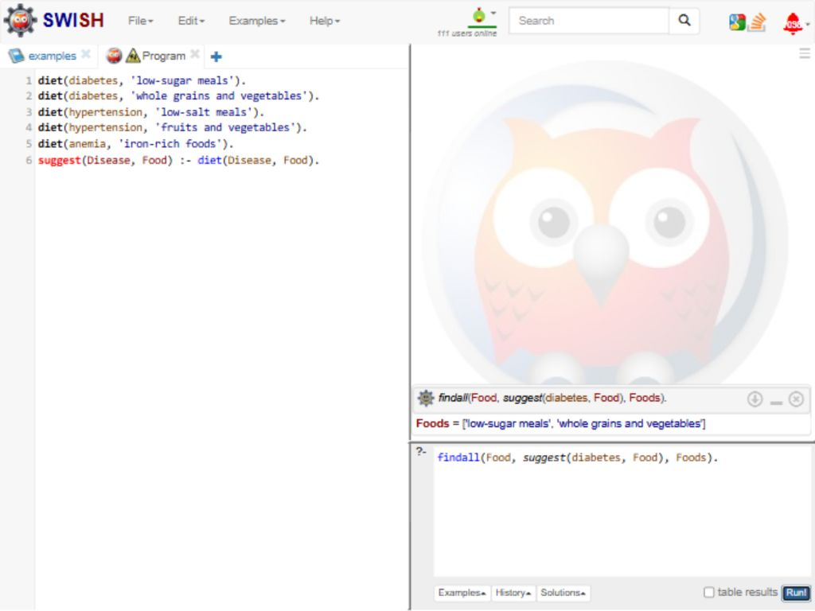
RESULT
Thus, the selected diseases returned their stored diet options.

CSA1708-ARTIFICIAL INTELLIGENCE
LAB EXPERIMENTS
Program 25 : Prolog Program for Monkey Banana Problem
Aim
To use Prolog rules to plan how a monkey reaches and takes bananas.
Algorithm
1. Represent the monkey, box, and goal as a state.
2. Define the walk, push, climb, and grab actions.
3. Apply actions recursively until the monkey has bananas.
4. Query the planner to display the action sequence.
Program
banana_at(middle).

action(state(M,B,floor,no), walk, state(B,B,floor,no)) :-
M \= B.
action(state(P,P,floor,no), push, state(middle,middle,floor,no)) :-
banana_at(middle), P \= middle.
action(state(middle,middle,floor,no), climb, state(middle,middle,box,no)).
action(state(middle,middle,box,no), grab, state(middle,middle,box,yes)).

plan(state(_,_,_,yes), []).
plan(S,[A|Rest]) :- action(S,A,N),
plan(N,Rest).

solution(Plan) :- plan(state(door,window,floor,no), Plan).
Sample Input
?- solution(Plan).
?- banana_at(middle).
Program Execution
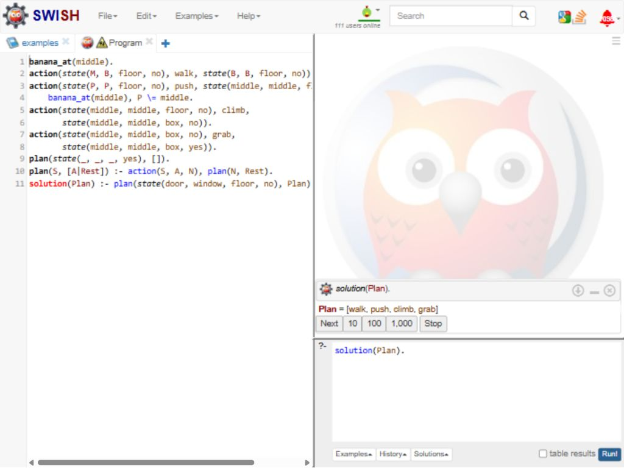
RESULT
Thus, Prolog generated an action plan and confirmed the banana location.

CSA1708-ARTIFICIAL INTELLIGENCE
LAB EXPERIMENTS
Program 26 : Prolog Program for Fruit Color Using Backtracking
Aim
To demonstrate Prolog backtracking by finding colors for a selected fruit.
Algorithm
1. Store fruit and color pairs as facts.
2. Query a fruit with a variable for its color.
3. Prolog returns the first matching color.
4. Use backtracking to find any additional matching colors.
Program
fruit_color(apple, red).
fruit_color(apple, green).
fruit_color(banana, yellow).
fruit_color(grape, purple).
fruit_color(orange, orange).
Sample Input
?- fruit_color(apple, Color).
?- fruit_color(banana, Color).
Program Execution
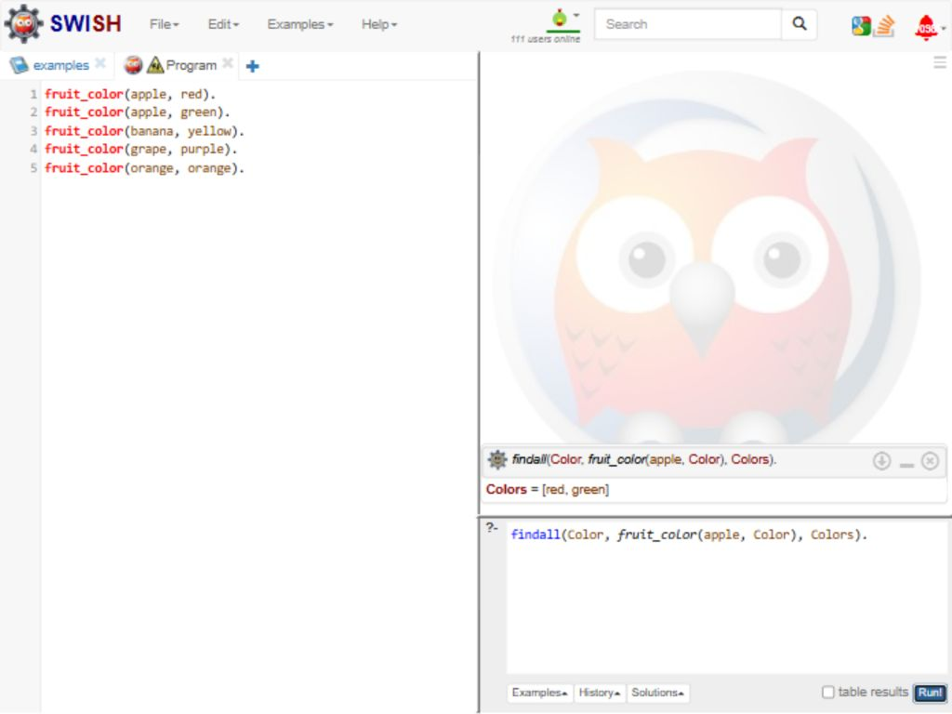
RESULT
Thus, backtracking found both stored apple colors, and the banana query returned yellow.

CSA1708-ARTIFICIAL INTELLIGENCE
LAB EXPERIMENTS
Program 27 : Prolog Program to Implement Best First Search
Aim
To find a goal path by expanding the node with the lowest heuristic value.
Algorithm
1. Store graph connections and heuristic values.
2. Add the start path to the open list.
3. Expand the path with the lowest heuristic value.
4. Return the path when the goal is selected.
Program
edge(start,left).
edge(start,right).
edge(left,goal).
edge(right,goal).
heuristic(start,3).
heuristic(left,2).
heuristic(right,1).
heuristic(goal,0).

best_first(S, G, P) :-
heuristic(S, H), search([H-[S]], G, R), reverse(R, P).
search([_-[G|P]|_], G, [G|P]).
search([_-[N|P]|Open], G, R) :-
findall(H-[X,N|P],
(edge(N,X), \+ member(X,[N|P]), heuristic(X,H)), Kids),
append(Open,Kids,All), keysort(All,Sorted),
search(Sorted,G,R).
Sample Input
?- best_first(start, goal, Path).
Program Execution
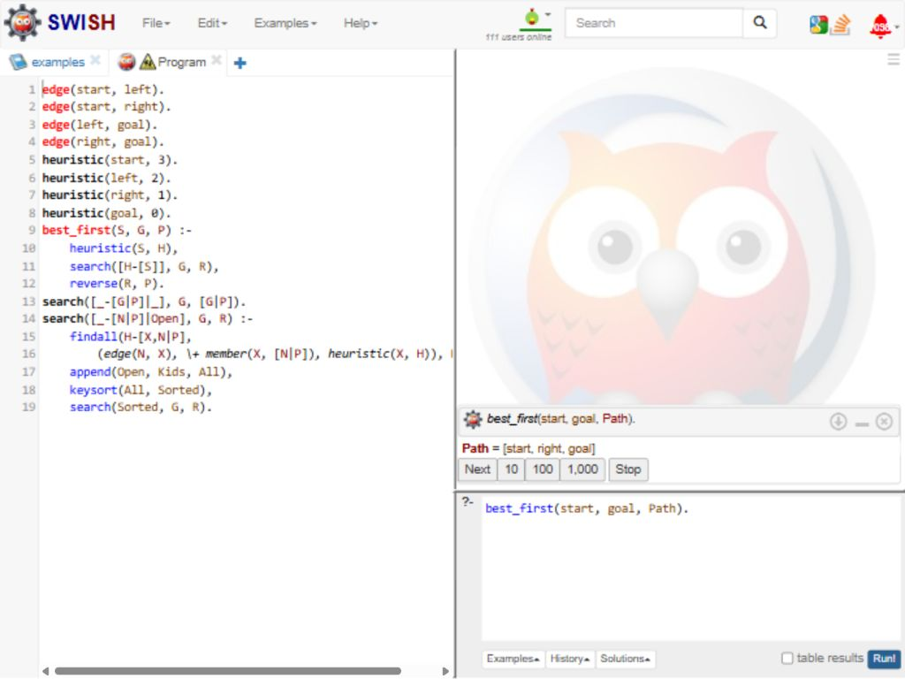
RESULT
Thus, Best-First Search returned the path start -> right -> goal.

CSA1708-ARTIFICIAL INTELLIGENCE
LAB EXPERIMENTS
Program 28 : Prolog Program for Medical Diagnosis
Aim
To illustrate Prolog rules that match sample symptoms to condition labels.
Algorithm
1. Store sample symptoms as facts.
2. Define rules that match symptoms to conditions.
3. Query the diagnosis predicate for a person.
4. Prolog returns any condition whose rule matches.
Program
symptom(amy, fever).
symptom(amy, cough).
symptom(amy, body_ache).
symptom(ben, sneezing).
symptom(ben, itchy_eyes).

diagnosis(P, flu) :-
symptom(P, fever),
symptom(P, cough),
symptom(P, body_ache).
diagnosis(P, allergy) :-
symptom(P, sneezing),
symptom(P, itchy_eyes).
Sample Input
?- diagnosis(amy, Disease).
?- diagnosis(ben, Disease).
Program Execution
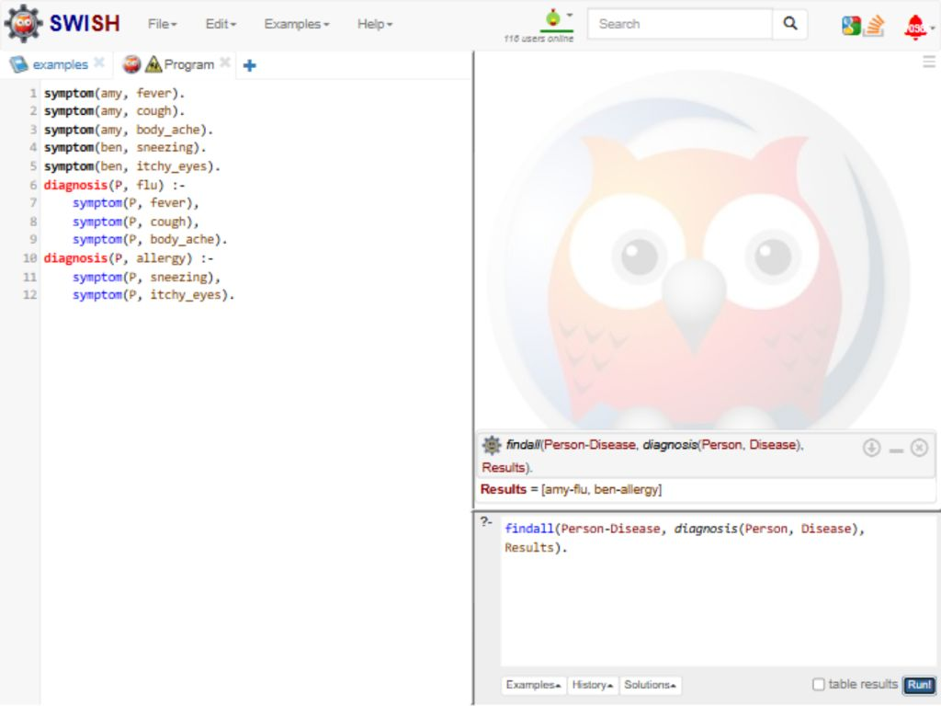
RESULT
Thus, the sample rules matched Amy with flu and Ben with allergy.

CSA1708-ARTIFICIAL INTELLIGENCE
LAB EXPERIMENTS
Program 29 : Prolog Program for Forward Chaining
Aim
To derive new facts repeatedly when their rule conditions are already known.
Algorithm
1. Store initial facts and rules.
2. Check whether a rule's conditions are known facts.
3. Add each new conclusion to the fact database.
4. Repeat until no new facts can be derived.
Program
:- dynamic fact/1.
fact(rain).
rule(wet_grass, [rain]).
rule(slippery_road, [wet_grass]).

forward_chain :-
rule(NewFact, Conditions),
forall(member(C, Conditions), fact(C)),
\+ fact(NewFact),
assertz(fact(NewFact)),
!,
forward_chain.
forward_chain.
Sample Input
?- forward_chain.
?- fact(X).
Program Execution
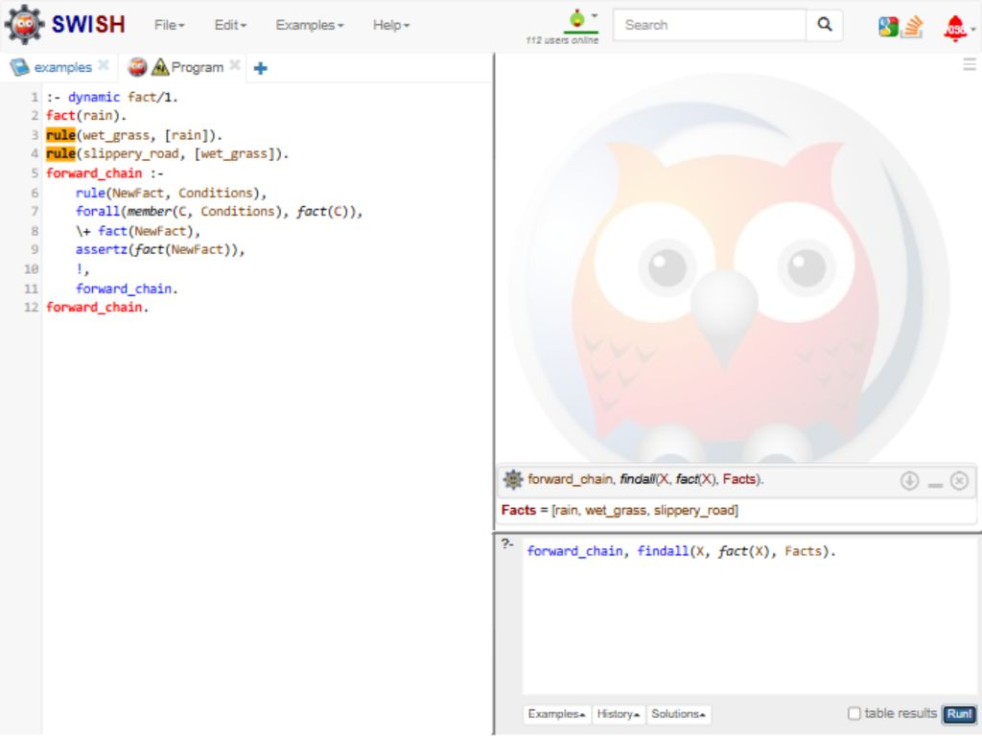
RESULT
Thus, forward chaining derived wet_grass and slippery_road from rain.

CSA1708-ARTIFICIAL INTELLIGENCE
LAB EXPERIMENTS
Program 30 : Prolog Program for Backward Chaining
Aim
To prove a query by working backward from its goal to known facts.
Algorithm
1. Start with a query goal.
2. Check whether the goal is a stored fact.
3. Match a rule and recursively prove its conditions.
4. Succeed if all conditions are proven; otherwise fail.
Program
fact(rain).
rule(wet_grass, [rain]).
rule(slippery_road, [wet_grass]).

backward_chain(Goal) :-
fact(Goal).
backward_chain(Goal) :-
rule(Goal, Conditions),
prove_all(Conditions).
prove_all([]).
prove_all([Goal|Rest]) :-
backward_chain(Goal),
prove_all(Rest).
Sample Input
?- backward_chain(slippery_road).
?- backward_chain(flooded_street).
Program Execution
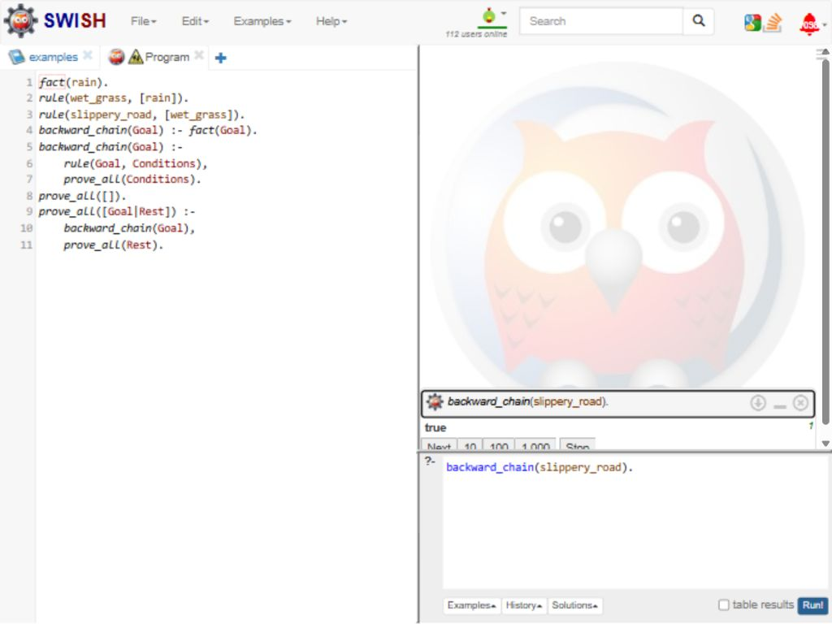
RESULT
Thus, backward chaining proved slippery_road; flooded_street failed.

